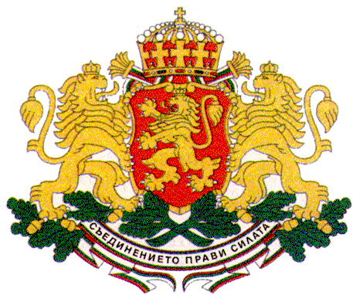 | PERMANENT MISSION OF THE REPUBLIC OF  BULGARIA  TO THE UNITED NATIONS

11 East 84th Street, New York, NY 10028, Tel: (212) 737 4790, Fax: (212) 472 9865, e-mail: bulgaria@un.int

70th UNGA, Third Committee
Item 28 (a-c) Social Development

Statement of Bulgarian Youth Delegates – Mr. Dimitar Dimitrov and Ms. Anina Yovkova

Mr. Chair,
Young people represent more than a hope for a brighter future – we embody the quest and inspiration for a more peaceful present. Youth has already proven that it possesses the vision, the creativity and the capacity to play a significant role in local, national and global decision-making processes. It is important that all countries ensure meaningful participation of young people at all levels and consider us as equal partners on global scale, bearing in mind our thriving potential as agents of positive change.

Mr. Chair,
In a recent survey that we have conducted as Youth Delegates, the young people of Bulgaria have identified quality education and professional realization as key prerequisites for youth development. Further efforts are required though to improve education at all levels in order to make it more adequate to the constantly changing market needs. To achieve that and to promote knowledge-based economies, youth should be included in all processes related to the drafting and elaboration of educational strategies, policies and practically-oriented university curricula. This would help young people obtain adequate skills and capacities for their future professional realization.

Providing quality education is even more important when speaking about young persons with disabilities to ensure their social inclusion and economic participation. For them to be able to realize their full potential, they need to be given opportunities to become active agents in all processes affecting their lives, not mere recipients of policies designed by others. Targeted measures aimed at the promotion of their greater involvement in the social and public life should be elaborated with the active participation of disabled persons’ organizations, civil society, youth representatives, the private sector and other stakeholders.

One possible tool for providing disabled persons with quality education is the introduction of non-formal educational practices. Schools and universities should also be made more accessible to young persons with disabilities. The recruitment of qualified young teachers meeting the special needs of disabled children and adolescents should also be further encouraged, including through financial incentives. On our part, the Bulgarian Youth Delegates are planning joint voluntary initiatives with young people with hearing impairment to improve their access to information, communication and social development.

Mr. Chair,
The power of non-formal education and the spirit of volunteering are crucial in addressing one of the most pressing youth issues – youth unemployment. Many Member States have identified different forms of non-formal training and volunteering as efficient tools for motivating young people to engage in lifelong learning, and to acquire useful skills to increase their employability and competitiveness on the job market. Bulgarian youth has consistently called for both public and private sectors’ official recognition of the knowledge obtained in the course of non-formal education.

Mr. Chair,
The Bulgarian youth welcomes the recent adoption of the Sustainable Development Goals and firmly believes that sustainable development is inextricably related and parallel to youth development. The Bulgarian Youth Delegates have actively raised awareness of the new global Agenda and its significance at national level. As a result, the young people of our country are ready to contribute to the implementation of the 2030 Agenda, for its success would be unthinkable without the equal youth participation in the process.
Today, when conflicts and humanitarian crises continue to deprive millions of people from their loved ones, their homes and even their lives, the human beings and their rights must remain at the core of the implementation of the 2030 Agenda – not only in words, but also in action.

The Bulgarian Youth Delegates and our team of volunteers have launched an initiative to promote better communication between young Bulgarians and refugees in our country. This could also help encourage more young people to participate as volunteers in projects and activities related to refugees’ integration in the society.

In the course of the initiative, our team established a bond of true friendship with Syrian and Iraqi children in a refugee camp through interactive games and creative activities. Before we left the camp, the children expressed their gratitude by giving us bracelets; they asked us when we would be coming back; and a little boy even said “I love you!” to one of our female volunteers.

We will most certainly be going back to this camp, for those who seem to possess the least, can actually give us the most – all of their love and affection!

Thank you, Mr. Chair!

